**GL Mapping Error as at 14-Mar-2017**

1. **Wrong Line Mapping of Interest Expense for Mortgage Loan at THL:**

Correct line: 0986-133110-Standard Loans – Real Estate Mortgage Loans – Individuals – Resident



Correct line: 3012-253110-AIR–Standard Loans–Real Estate Mortgage Loans–Individuals–Resident



Wrong line mapping to: 0251-512610-Interest Income-Standard Loans-Saving Deposit

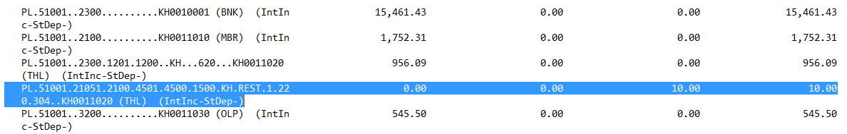

Should be remap to line: 1706-533110-Interest Income–Standard Loans–Real Estate Mortgage Loans–Individuals–Resident



1. **Error Amount of Fixed Deposit (Minus Balance) at MBR:**

**0356-121330**

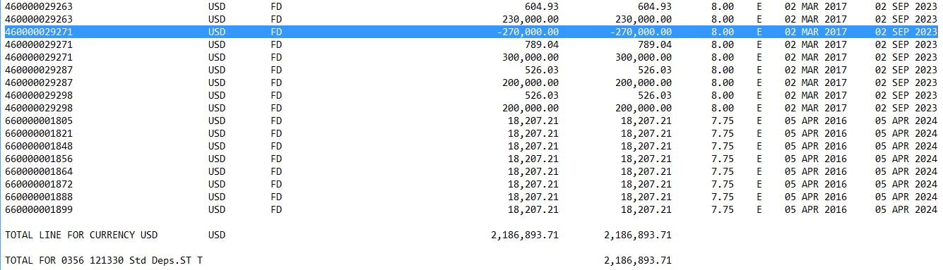

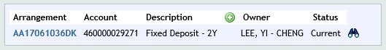

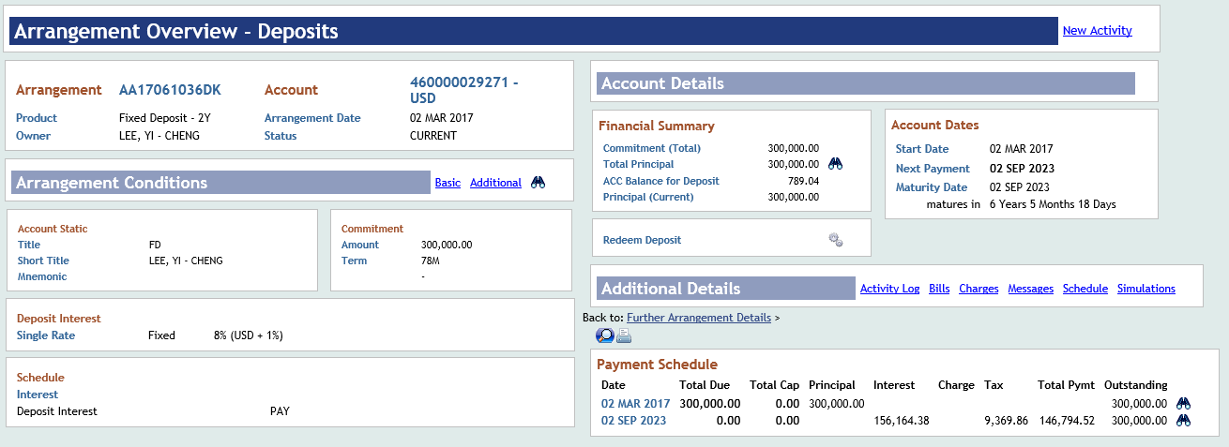

1. **Error Amount in PL-Catch All at MBR:**

